Complex Analysis Qualifying Exam, Spring 2013 (January 4, 2013)

Problems

  - Let $u$ be a real-valued harmonic function on a simply connected domain $D⊂C$. Prove that there is a function $v$ (the harmonic conjugate of $u$) defined on $D$ such that $f=u+iv$ is holomorphic.
  - Find the harmonic conjugate of $u(x+iy)=xe^{x}cos(y)-ye^{x}sin(y)$.
- Evaluate
$$\int_{-∞}^{∞}{\frac{x^{2}}{x^{4}+1}} dx.$$
- Let $D$ denote the intersection of the two open disks $|z±i/\sqrt{3}|<2/\sqrt{3}$. Find a one-to-one conformal map from $D$ onto the half-plane $Re(z)>0$.
- 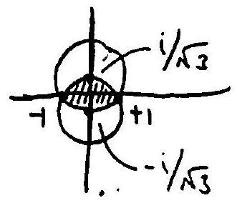

  - Prove that on the complement (in $C$) of the interval $[-1,1]$, there is a holomorphic function $f(z)$ such that $e^{f(z)}=\frac{z-1}{z+1}$. (Hint: Consider the image of the right hand side. Alternatively, take the derivative of both sides.)
  - Show furthermore that $f$ cannot be extended holomorphically to the complement of $\{-1,1\}$.
  - Find the Laurent expansion of $f$ in the annulus $1<|z|<∞$. Note that $f$ is not unique - your answer will have a parameter.
- Prove that for every nonnegative integer $n$, the polynomial $f_{n}(z)=\sum_{k=0}^{n}{\frac{z^{k}}{k!}}$ has no roots in the open unit disk. (Hint: Check $n=1$ and $n=2$ directly.)
- Consider the function $f(z)=\frac{1}{sinz}$, defined on $C-πZ$.
  - Show that $f$ cannot be approximated uniformly by polynomials on compact subsets of $C∖πZ$, i.e. there is no sequence $p_{1}(z),p_{2}(z),…$ of polynomials such that for every compact $K⊂C∖πZ$ the sequence $p_{n}→f$ uniformly on $K$.
  - Show that, on the other hand, it is possible to approximate $f$ uniformly by polynomials on any compact disk contained in $C∖πZ$.

